GOOGLE SCHOLAR REPORT
MAKING A NEW SCHOLAR PROFILE (DR. Zartash)

1) ANALYZING DR.Zartash’s profile

→Profile Name: Zartash Uzmi
→ Total Articles on Profile: 83
→ Total Citations: 1259

→ Fake Citations in Original Dr.Zartash Profile:
A total of 8 fake citations out of a total of 1259 citations.
A total of 2 articles not belonging to Sir Zartash out of 83.
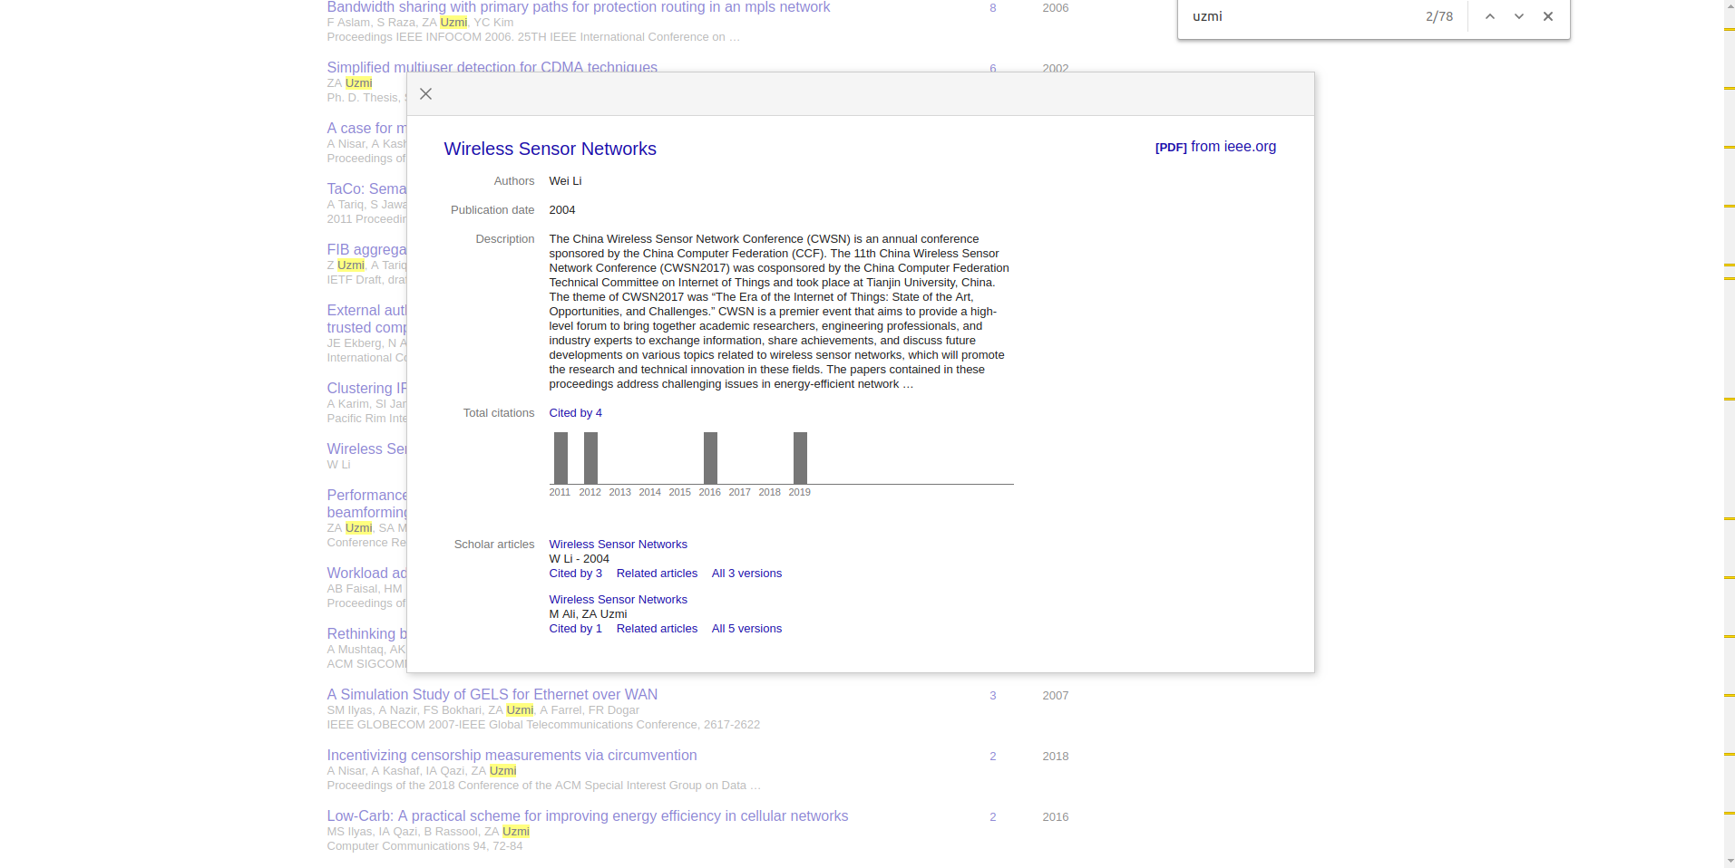
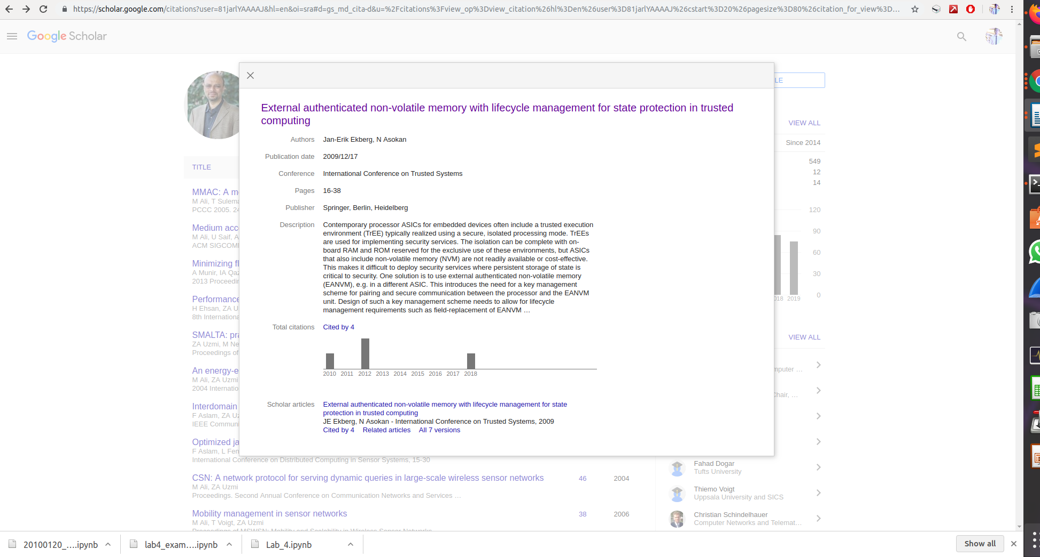

→ Anomalies:
An article with name “test01” shows an invalid link.
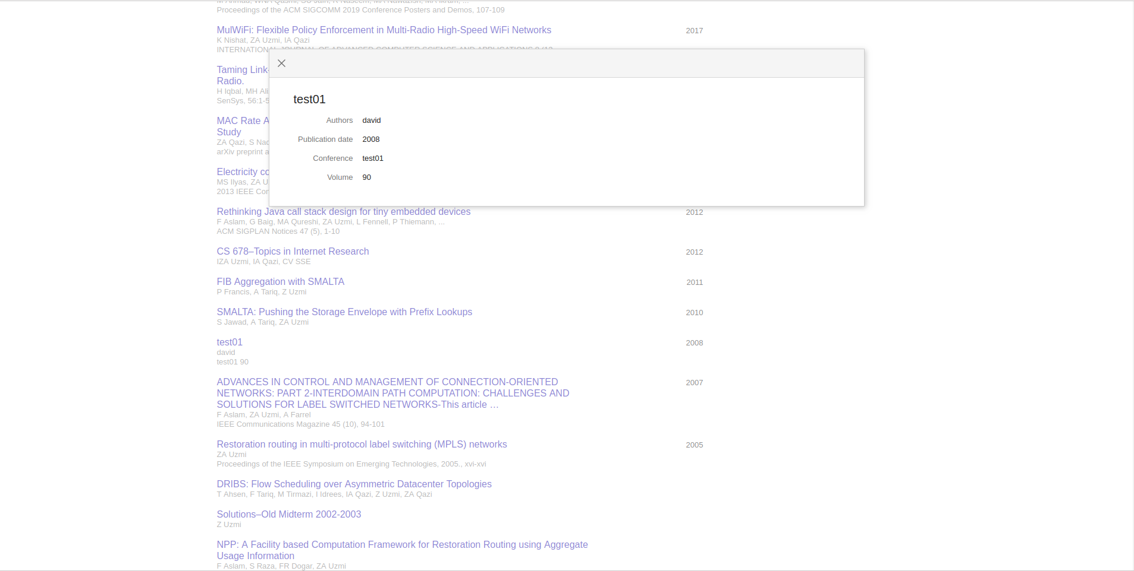

2) CREATING A NEW PROFILE WITH SAME NAME

Step 1: Filled Information just as it is on Dr. Zartash’s Scholar profile.
→ Used my Gmail ID.

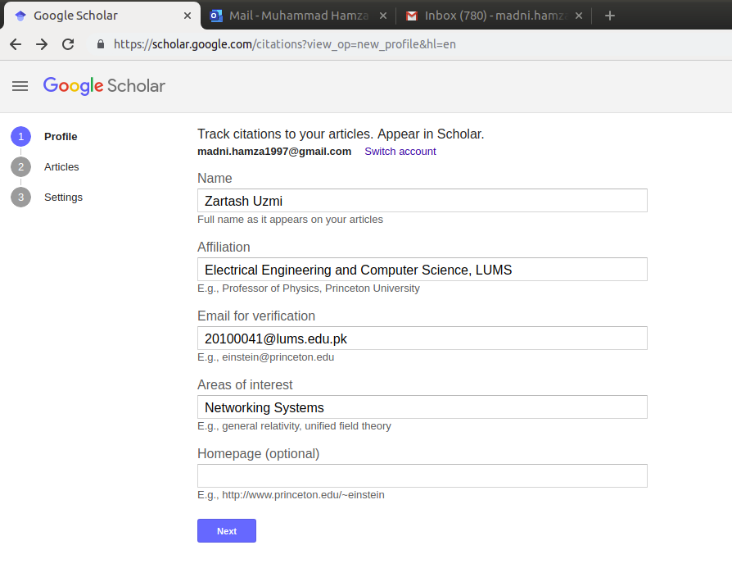

Step 2: Selecting Articles

→ The profile shows BY DEFAULT grouped articles. These articles were grouped by Google Scholar itself based on naming conventions used generally (Probably).
Total of 77 in this case grouped into a single check box and can be selected altogether.
- If we click on “77 articles”; it shows the details for all of those 77 articles and their respective links.
- All of them have Dr. Zartash as an author listed.
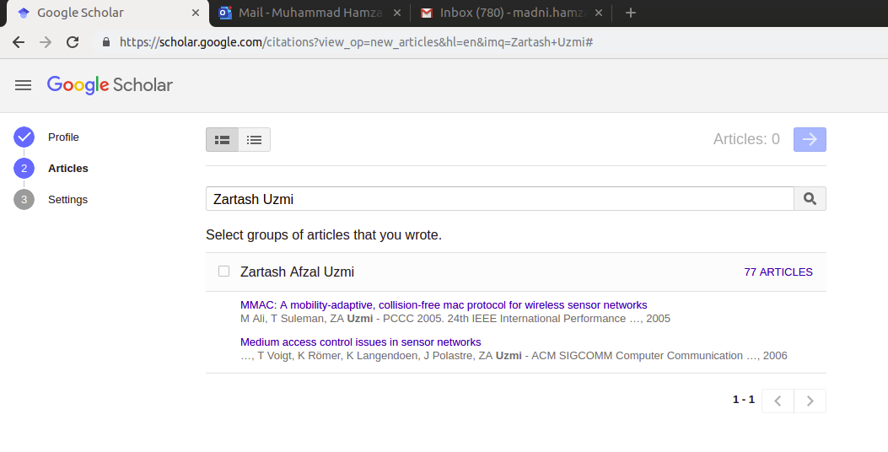
→ Selecting the List view for these articles, gives an option to select each articles manually from the given list of articles (which supposedly never ends since I tried going up till 1000 articles).
The first 70-80 articles contain Dr. Zartash as an author listed but as we go deeper into the list, we start to get articles that do not list Dr. Zartash as an author.
- These profiles can still be selected for being a part of our profile.

Step 3: Selected the initial articles for the profile and then set update settings.

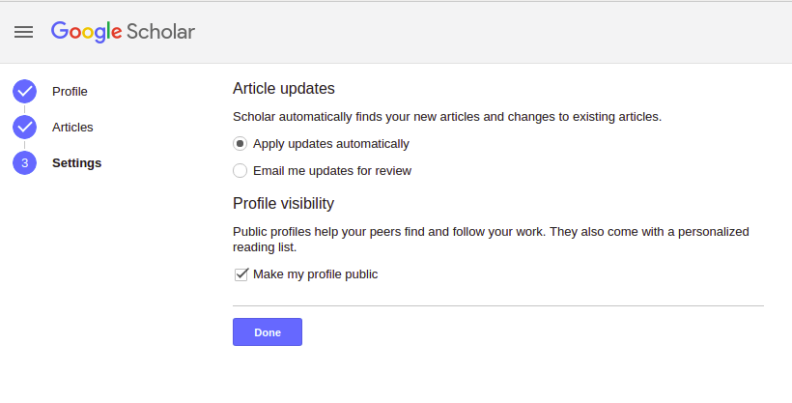
→ Final Profile created:

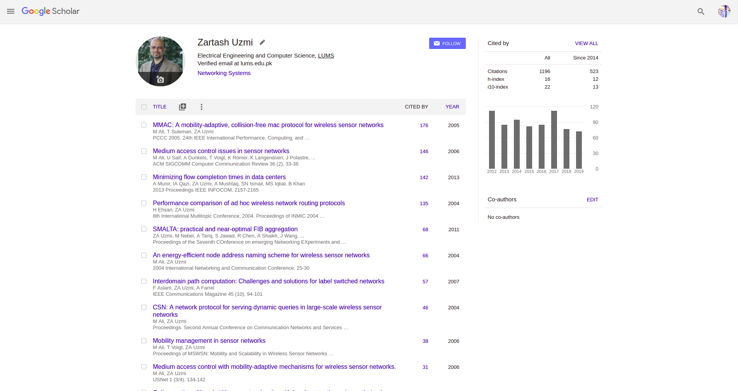

Step 4: Adding new articles:
Gives 3 options:
- Add articles by group. (Already done that so there is no group to select there now)
- Add articles by List View. (Shows the same list of articles as before. We can select the articles we want from it. Recommendations are given based on some features that Google uses to identify similarity).
- Add articles manually. (You add the article name, authors and some other details and a new article is appended to your scholar profile)

Add article manually:

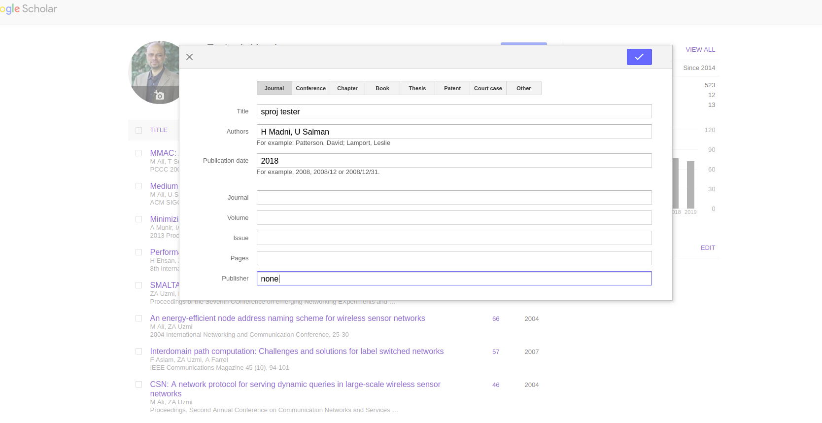
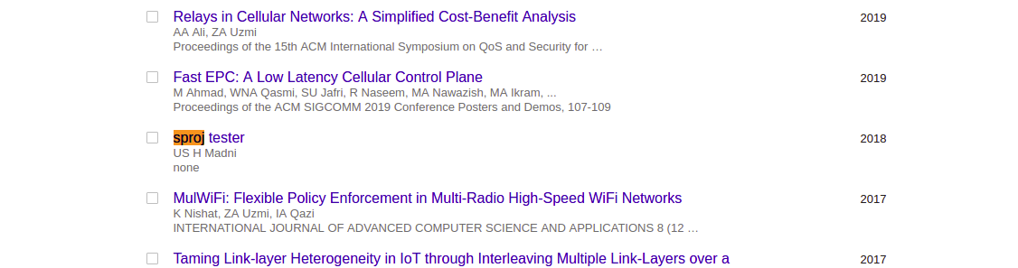

→ The updates to existing articles and newer article recommendations will be automatically posted on this profile while the changes will also be sent to me via email.

LINK: https://scholar.google.com/citations?hl=en&user=k-2n5MQAAAAJ

